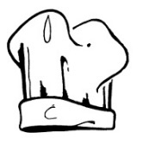
THE CHEF'S RULES

I. The chef is right.

II. The chef is always right.

III. Even if an underling is right, article I applies.

IV. The chef doesn't eat, he nourishes himself.

V. The chef doesn't drink, he tastes.

VI. The chef doesn't sleep, he rests himself.

VII. The chef is never late, he is detained.

VIII. The chef never leaves his service; he is called away.

IX. The chef never reads his newspaper on the job, he studies it.

X. You go into the chef's office with your own ideas, and you come out with the chef's ideas.

XI. The chef remains the chef, even in a bathing suit.

XII. The more you criticise the chef, the fewer bonuses you will receive.

XIII. The Chef must think for everyone else.

